**Persistent Data Strategy**

for the PAS project

## Deployment diagram

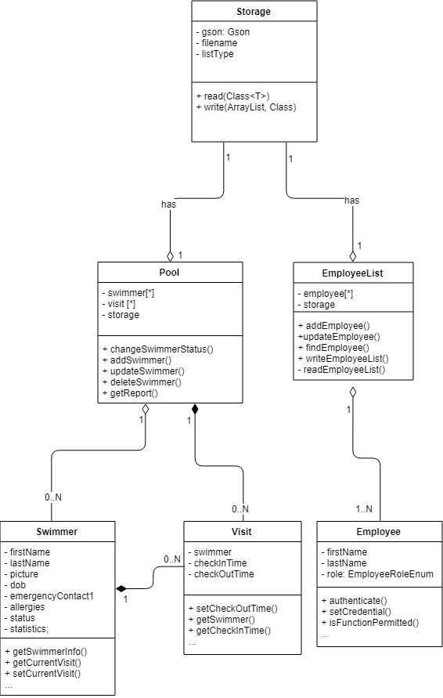

## Description:

In this project, we decided to implement the GSON method for the persistence. There are three collections (of ArrayList type) that must be persistently stored: swimmers list (customers data), employee list (access privileges), and the list of visits (for logging purposes). To avoid duplicative code for handling read/write operations in each class, we created a new class, called Storage to process all read/write requests. The Storage class has only two public methods: read and write. By using abstract classes as arguments, these methods support reading and writing of ArrayLists of any class, including Swimmer, Visit, and Employee. This technique allows us to achieve better separation of concerns and improve code reusability.